A
PROJECT REPORT
ON
“CSE INSIGHT HUB”
BACHELOR OF TECHNOLOGY
IN
COMPUTER SCIENCE AND ENGINEERING (CYBERSECURITY)
BY
- SHRUTHI - 24N81A6214
P. KAVYA JAYASREE - 24N81A6231
L. NIKHITHA - 24N81A6228
M. PALLAVI - 24N81A6229
J. ASHWINI - 24N81A6217
Under the Guidance of
Mrs. A.Sandhya Rani
Assistant Professor
Department of CSE (CYBER SECURITY)


DEPARTMENT OF COMPUTER SCIENCE AND ENGINEERING (CS) SPHOORTHY ENGINEERING COLLEGE
Nadergul (Vill.), Near L.B. Nagar, Hyderabad, Telangana – 501510.
[2024-2028]

SPHOORTHY ENGINEERING COLLEGE
DEPARTMENT OF COMPUTER SCIENCE AND ENGINEERING (CS)

CERTIFICATE
This is to certify that this Real Time Research Project Report entitled CSE INSIGHT HUB is a Bonafide work carried out by P. Kavya Jayasree 24N81A6231, A.Shruthi 24N81A6214, M.Pallavi 24N81A6229, L.Nikhitha 24N81A6228, J.Ashwini 24N81A6217 in partial fulfilment of the requirements for the award of degree of Bachelor of Technology in Computer Science and Engineering (CS) from Sphoorthy Engineering College, affiliated to Jawaharlal Nehru Technological University Hyderabad, during the Academic Year 2025-26 under our guidance and supervision.
The results embodied in this report have not been submitted to any other university or institute for the award of any degree or diploma.

Internal Guide Head of the Department
Mrs. A.Sandhya Rani
Assistant Professor
Department of CSE (CS) SPHN

DECLARATION
We the undersigned, declare that the Real Time Research Project Report “CSE INSIGHT HUB” carried out at “SPHOORTHY ENGINEERING COLLEGE” is original and is being submitted to the Department of COMPUTER SCIENCE AND ENGINEERING (CYBERSECURITY), Sphoorthy Engineering College, Hyderabad towards partial fulfilment for the award of degree of Bachelor of Technology.
We declare that the result embodied in the the Real Time Research Project Report has not been submitted to any other University or Institute for the award of any Degree or Diploma.
Date:
Place:
GROUP MEMBERS:
- SHRUTHI - 24N81A6214
P. KAVYA JAYASREE - 24N81A6231
L. NIKHITHA - 24N81A6228
M. PALLAVI - 24N81A6229
J. ASHWINI - 24N81A6217

ACKNOWLEDGEMENT
We sincerely thank our Project Guide Mrs. A. Sandhya Rani, Asst. Professor, Department of Computer Science & Engineering (CYBERSECURITY), Sphoorthy Engineering College, for her inspiring guidance, consistent encouragement, constructive criticism and helpful suggestions during the entire course of my project work.
We express our sincere thanks to Mrs. P. Sandhya Rani, Professor & Head of the Department, Department of Computer Science & Engineering (CS), Sphoorthy Engineering College, Nadergul (V), Balapur (M), Ranga Reddy (D) for their encouragement which helped us to complete the Project work.
We deem it a great privilege to express our profound gratitude and sincere thanks to Mr. S. Chalama Reddy, Chairman, Mr. S. Jagan Mohan Reddy, Secretary, Dr. K. Srinivas Rao, Principal, Sphoorthy Engineering College, Nadergul (V), Balapur (M), Ranga Reddy (D), for their moral support and help in the completion of the project work.
We express our heartfelt thanks to Professors, Associate Professors, Assistant Professor and other professional non-teaching staff of Department of Computer Science and Engineering (CS), Sphoorthy Engineering College, Nadergul (V), Balapur (M), Ranga Reddy (D) for providing the necessary information pertaining to our project work.
BATCH: 2024 – 2028
GROUP MEMBERS:
- SHRUTHI - 24N81A6214
P. KAVYA JAYASREE - 24N81A6231
L. NIKHITHA - 24N81A6228
M. PALLAVI - 24N81A6229
J. ASHWINI - 24N81A6217

J.ASHWINI - 24N81A6217

ABSTRACT
CSE Insight Hub is a centralized platform developed to support Computer Science and Engineering students by providing academic and career-related resources in one place. The system is designed to help students access project ideas, study materials, technical information, placement preparation content, internship details, coding resources, and career guidance efficiently.
The main objective of this project is to create an easy-to-use platform that improves learning, skill development, and knowledge sharing among students. It provides organized information related to programming languages, emerging technologies, research topics, and industry trends, helping students stay updated with the latest developments in the field of computer science.
The platform also aims to reduce the difficulty students face while searching for learning resources from multiple sources by integrating all required information into a single system. It supports academic growth, project development, and placement preparation, making it beneficial for students throughout their educational journey.
CSE Insight Hub acts as an informative and collaborative environment that enhances technical knowledge, promotes self-learning, and prepares students for future career opportunities in the technology domain.
Overall, CSE Insight Hub serves as an educational support and knowledge-sharing platform that enhances learning experiences, improves academic performance, and prepares students for professional growth in the field of Computer Science and Engineering.

GROUP MEMBERS:
A.SHRUTHI - 24N81A6214
P.KAVYA JAYASREE - 24N81A6231
L.NIKITHA - 24N81A6228
M.PALLAVI - 24N81A6229
J.ASHWINI - 24N81A6217

I

INDEX
II
Contents |  |  | Page No.
Abstract |  |  | I
Index |  |  | II
List of Figures |  |  | III
CHAPTERS
1. | Introduction |  | 1
 | 1.1 | Problem Statement | 1
 | 1.2. | Objective | 1
 | 1.3. | Existing System | 1
 | 1.4. | Proposed System | 2
 | 1.5. | Scope | 2
 | 1.6. | Software & Hardware Requirements | 3
2. | Literature Survey |  | 4
 | 2.1. | Survey of Major Area Relevant to Project | 4
 | 2.2. | Techniques and Algorithms | 4
 | 2.3. | Applications | 5
3. | System Design |  | 6
 | 3.1. | System Architecture | 6
 | 3.2. | System Flow | 6
 | 3.3. | Module Description | 7
 | 3.4. | UML Diagram | 8
4. | Implementation |  | 13
 | 4.1. | Environmental Setup | 13
 |  | 4.1.1 Development Environment | 13
 | 4.2. | Implementation of Modules | 13
 | 4.3. | Integration and Development | 15
5. | Evaluation |  | 16
 | 5.1. | Modules | 16
 | 5.2. | Evaluation Metrics | 17
 | 5.3. | Test Cases | 17
 | 5.4 | Results | 23
6. | Conclusion and Future Enhancement |  | 24
 | References |  | 26
 | Appendix and Sample code |  | 27

LIST OF FIGURES
Figure No. | Figure Name | Page No.
3.2.1 | Use Case Diagram | 8
3.2.2 | Class Diagram | 9
3.2.3 | Sequence Diagram | 9
3.2.4 | Activity Diagram | 10
5.3.1 | EAPCET Rank Entry Page | 17
5.3.2 | Technologies Exploration Dashboard | 18
5.3.3 | Skill&Interests Enhancement Test | 20
5.3.4 | Career Path Guide | 21
5.3.5 | Domian Benefits Information Page | 23

III

CHAPTER-1
INTRODUCTION
  - PROBLEM STATEMENT
Computer Science and Engineering students face difficulties in finding study materials, project resources, placement content, and technical information because these resources are available on different platforms. This creates confusion and consumes time.
CSE Insight Hub is developed to provide all academic and career-related resources in a single platform for easy access and better learning support.
  - OBJECTIVE
The objective of CSE Insight Hub is to develop a centralized platform that provides Computer Science and Engineering students with easy access to study materials, project resources, technical content, placement preparation materials, and career guidance in a single system. The platform aims to improve learning, skill development, and academic support for students.
  - EXISTING SYSTEM
This process is time-consuming and creates difficulty in finding organized and reliable information. The lack of a centralized system reduces learning efficiency and resource accessibility for students.
Drawbacks:
- Resources are available on multiple platforms and websites.
- Searching for information consumes more time.
- Lack of centralized access to learning materials.
- Difficulty in finding organized and reliable resources.

  - PROPOSED SYSTEM
The proposed system, CSE Insight Hub, is a centralized platform designed to provide Computer Science and Engineering students with study materials, project resources, technical content, placement preparation materials, and career guidance in a single system. It offers easy access to organized information, improves learning efficiency, and supports academic and career development.

Key Features of Proposed System
- EAPCET rank-based career guidance
- Trending technology exploration
- Interest and skill assessment
- Personalized career recommendations
- College suggestion support
- Simple and user-friendly interface

Working of the System
- User enters EAPCET rank.
- System displays trending technology domains.
- User completes skill and interest assessment.
- System analyzes responses and rank.
- Recommended career path is generated.
- Benefits and college suggestions are displayed
  - SCOPE
- Helps students choose suitable career domains.
- Provides awareness about trending technologies.
- Assists in career and college selection.
- Supports student skill analysis and guidance.

Applications:
- Career guidance systems
- Educational counseling platforms
- College recommendation systems
- Student assessment applications.

Future Scope:
- AI-based smart recommendation
- Real-time college cutoff analysis
- Internship and placement support
- Integration with online learning platforms
- Chatbot support for students

  - SOFTWARE AND HARDWARE REQUIREMENTS
Software Requirements
- Operating System: Windows 10 / Windows 11
- Programming Language: Python, HTML, CSS, JavaScript
- Compiler / IDE: Visual Studio Code
- Libraries: Pandas, NumPy, Matplotlib, Tkinter

Hardware Requirements
- RAM: 4 GB (Minimum), 8 GB Recommended
- Storage: 50 GB Free Disk Space (Minimum)
- System Type: 64-bit Operating System, x64-based Processor
- Processor: Intel Core i3 / Intel Core i5 or equivalent AMD processor (Minimum 2.0 GHz)

CHAPTER-2
LITERATURE SURVEY
2.1 SURVEY OF MAJOR AREA RELEVANT TO PROJECT
The project covers multiple important areas in computer science and security:

Academic Resource Management Systems :

Academic resource management systems are used to provide study materials, notes, assignments, and educational content in an organized manner. These systems improve accessibility and help students obtain learning resources efficiently.

Learning Management Systems (LMS):

Learning Management Systems support online learning, content sharing, course management, and student interaction. They provide a digital environment for learning and educational activities.

Project Management and Guidance Systems
Project support platforms help students access project ideas, documentation, implementation guidance, and technical resources required for academic projects.

Placement Preparation Systems
Placement preparation platforms provide aptitude materials, interview questions, resume guidance, and technical preparation resources to improve student employability.

2.2 TECHNIQUES AND ALGORITHMS
Centralized Data Management
Used to store and organize placement content, and technical information in a single platform.
User Interface Design
A user-friendly interface is used for easy navigation and quick access to resources.
Information Management Technique
Used to categorize and manage academic and career-related information efficiently.

Search Algorithm
Used to search various domains and resources based on user requirements.
Sorting Algorithm
Used to arrange resources and content in an organized order.

2.3 APPLICATIONS
CSE Insight Hub is used for career guidance, technology domain exploration, skill assessment, and college recommendations. It helps students choose suitable career paths based on their interests, skills, and EAPCET rank.

CHAPTER-3
SYSTEM DESIGN
The CSE Insight Hub system is designed as a centralized platform that manages placement materials and technical content for students.

Modules of System Design
1. Rank Input Module – Accepts the user’s EAPCET rank.
2. Technology Exploration Module – Displays trending technology domains.
3. Skill Assessment Module – Collects user interests and skills.
4. Recommendation Module – Suggests suitable career paths.
5. College Recommendation Module – Displays suitable colleges.
6. User Interface Module – Provides smooth interaction between user and system.

3.1 SYSTEM ARCHITECTURE
The system follows a user-centered architecture where the user interacts with the web interface to enter rank details and complete assessments. The backend processes the information and generates career and college recommendations. The database stores user data, technology information, and recommendation details.

Simple Architecture Flow:
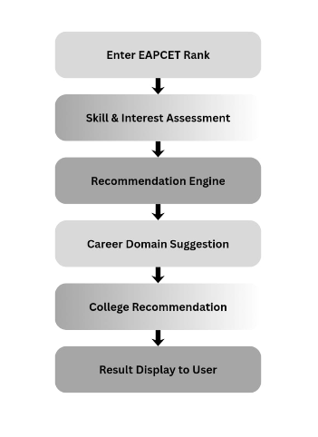
3.2 SYSTEM FLOW
Step-by-step working flow:
Step 1: User Accesses the System
Step 2: Enter EAPCET Rank
Step 3: Explore Technology Domains
Step 4: Skill & Interest Assessment
Step 5: Data Analysis
Step 6: Recommendation Generation
Step 7: College Recommendation
Step 8: Result Display

3.3 MODULE DESCRIPTION
The system consists of the following modules:
1. User Interface Module
Provides interaction between the user and the system.
2. Rank Input Module
Accepts and validates the EAPCET rank.
3. Technology Exploration Module
Displays trending technology domains.
4. Skill Assessment Module
Collects user interests and skill information.
5. Recommendation Module
Analyzes user data and generates career recommendations.
6. College Recommendation Module
Suggests suitable colleges based on rank and domain.
7. Database Module
Stores user data, technology details, and recommendation information.

3.4 UML DIAGRAM

1. Use Case Diagram
Actors: Student / User, Admin
Use Cases:
- Enter EAPCET Rank
- Explore Technology Domains
- Complete Skill Assessment
- Get Career Recommendations
- View College Suggestions
- View Career Guidance Results
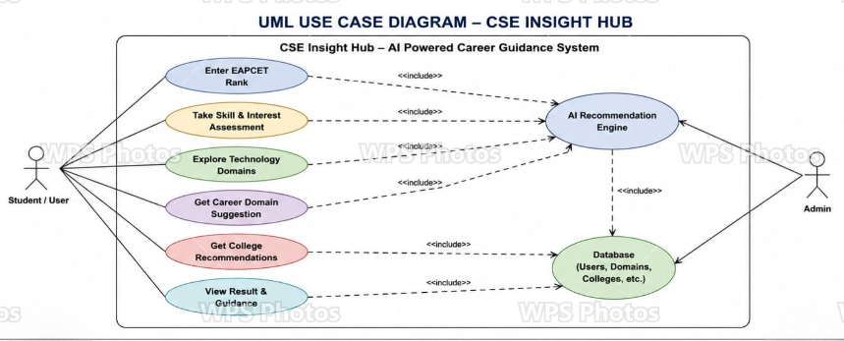 Fig 3.2.1 Use Case Diagram
2. Class Diagram
Main Classes:
Classes
User
- userID
- name
- rank
Assessment
- assessmentID
- skills
- interests
Recommendation
- recommendationID
- careerDomain
College
- collegeID
- collegeName
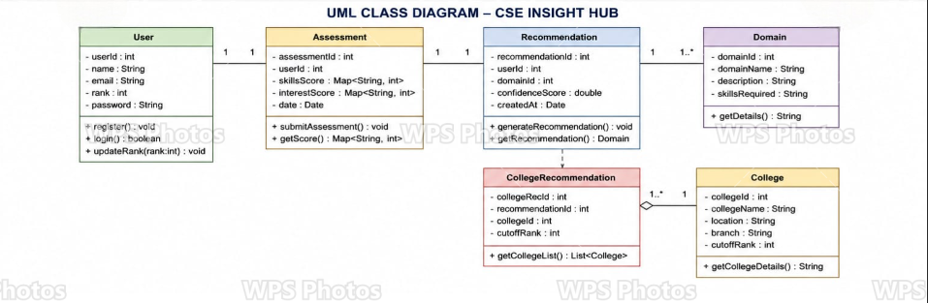
Fig 3.2.2 Class Diagram

- Sequence Diagram (Login & Access Control)
- User: Sends login request and selects the required module.
- Login System: Verifies user login details.
- Module Controller: Processes user requests and manages modules.
- Resource Manager: Retrieves required resources and information.
- System: Displays the requested information to the user.

Flow:

Login Request → Validate User → Login Success → Select Module → Request Data → Retrieve Data → Display Information

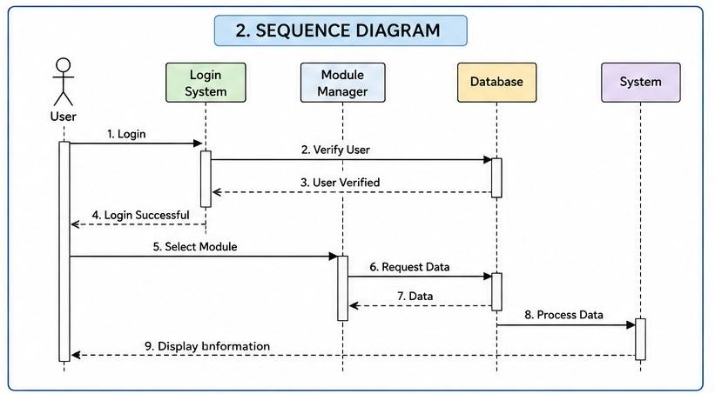
Fig 3.2.3 Sequence Diagram

- Activity Diagram
- Start: User starts the system.
- Login: User enters the platform.
- Select Module: User chooses rank, domain, placement, or technical content.
- Process Request: System processes the selected request.
- Retrieve Data: Information is fetched from the database.
- Display Information: System shows the required data to the user.
- End: Process complete
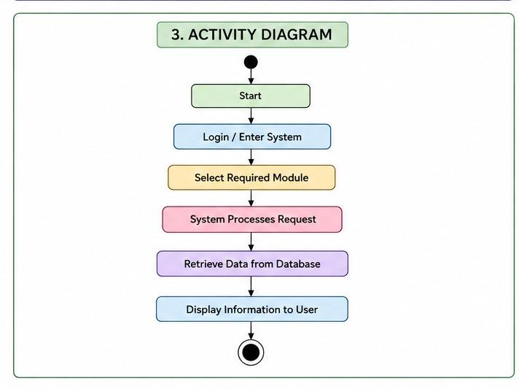
Fig 3.2.4 Activity Diagram

CHAPTER-4
IMPLEMENTATION
4.1 ENVIRONMENT SETUP
The environment setup for CSE Insight Hub involves installing the required software and tools for system development and execution. The system uses Windows 10 / Windows 11 as the operating system with Python as the programming language and Visual Studio Code or PyCharm as the development environment. Required libraries such as Pandas, NumPy, Matplotlib, and Tkinter are installed for project functionality. MySQL is used for database management, and XAMPP / Localhost Server is configured for application execution. After installing all components, the project files and database connections are set up to run the system successfully.
4.1.1 Development Environment
- Operating System: Windows 10 / Windows 11
- Programming Languages: Python, HTML, CSS, JavaScript
- Development Tools / IDE: Visual Studio Code, PyCharm
- Database: MySQL
- Libraries: Pandas, NumPy, Matplotlib, Tkinter
- Server Environment: XAMPP / Localhost Server
- Web Browser: Google Chrome / Microsoft Edge
- Version Control: Git (Optional)
Setup Steps:
- Install Windows 10 / Windows 11 operating system.
- Install Python programming language.
- Install Visual Studio Code / PyCharm IDE.
- Install required libraries (Pandas, NumPy, Matplotlib, Tkinter).
- Install and configure MySQL database.
- Install XAMPP / Localhost Server.
- Create project files and configure database connection.
- Run the application and test system functionality.
4.2 IMPLEMENTATION OF MODULES

User Module

The User Module is implemented to allow students to access the CSE Insight Hub platform and utilize available resources. It manages user access, navigation, and interaction with different modules in the system.

Placement Module

The Placement Module is implemented to support placement preparation by providing aptitude materials, interview questions, resume guidance, and preparation resources.

Technical Content Module

The Technical Content Module is implemented to provide coding resources, technical information, and updates related to programming and emerging technologies.

Database Module

The Database Module is implemented to store, manage, retrieve, and update all system information including study materials, project data, placement resources, and technical content.
4.3 INTEGRATION AND DEVELOPMENT
Development
Creation of the CSE Insight Hub platform using frontend, backend, and database technologies. Modules such as study materials, coding resources, placements, and project management are developed.
Integration
Combining all modules into a single system by connecting frontend, backend, database, and authentication services.
Testing and Refinement
Testing the system to identify errors, improve performance, fix bugs, and enhance user experience.
Deployment
Hosting the completed system on a server and making it accessible for users with proper security and maintenance.

CHAPTER-5
EVALUATION
5.1 MODULES
Evaluation of CSE Insight Hub is carried out to measure the performance, usability, efficiency, and reliability of the system. The platform is evaluated based on user satisfaction, system response time, accuracy of data management, and overall functionality. Feedback from students and faculty helps in improving the system and ensuring better performance.
Authentication Module (Login & Verification Module)
The Authentication Module manages secure user login and verification in the CSE Insight Hub system. It allows students and faculty to access the platform using authorized credentials. The module verifies user identity, protects user data, and prevents unauthorized access. It also supports password validation and secure session management
Access Control Module
The Access Control Module manages user permissions and restricts access based on user roles. It ensures that students, faculty, and administrators can only access authorized features and data within the CSE Insight Hub system. This module improves security, protects sensitive information, and maintains proper control over system operations.
Security & Monitoring Module (Intrusion Detection Module)
The Security and Monitoring Module protects the CSE Insight Hub system from unauthorized access, cyber threats, and suspicious activities. It continuously monitors system operations and detects unusual behavior or intrusion attempts. The module helps maintain data security, system reliability, and safe user access through real-time monitoring and alert mechanisms.
5.2 EVALUATION METRICS
- Identify the performance requirements of the system.
- Measure system accuracy and response time.
- Evaluate security and data protection efficiency.
- Check system reliability and availability.
- Collect feedback from users for satisfaction analysis.
- Analyze errors and system performance issues.
- Compare results with expected objectives.
- Improve the system based on evaluation results.
5.3 TEST CASES

Requirement Analysis
Understand all modules of the system:
- Login & Registration
- Dashboard
- Resource Upload
- Search Function
- Discussion Forum
- Admin Panel
- Notifications

Test Planning
- Decide what to test (modules & features)
- Select testing types:
  - Functional testing
  - Security testing
  - Performance testing
- Prepare test environment (system, browser, database)

Test Case Design
- Write test cases for each module
- Include:
  - Valid inputs (positive testing)
  - Invalid inputs (negative testing)
- Define expected results for each case

Test Environment Setup
- Install required software (frontend, backend, database)
- Configure server and database connection
- Ensure application is ready to run

Login Module
- Enter valid username/password → check login success
- Enter wrong password → check error message
- Leave fields empty → check validation

Registration Module
- Enter valid details → account created
- Use duplicate email → error shown
- Enter invalid email → validation error

Dashboard Module
- Login → dashboard should load
- Click menus → proper navigation

Search Function
- Enter keyword → results shown
- Enter wrong keyword → no results message

Forum Module
- Post question → appears in forum
- Add comment → stored successfully

Admin Module
- Admin login → access granted
- Block user → user disabled

Notification Module
- Trigger event → notification received
- Open notification → marked as read

Bug Reporting
- If any test fails:
  - Record bug details
  - Mention module, error, and steps to reproduce
- Send to development team

Bug Fixing & Retesting
- Developers fix issues
- Tester rechecks the same test cases
- Confirm issue is resolved

Final Testing
- Run all modules again
- Ensure system is stable
- Check performance and security

Test Closure
- Prepare final test report
- Document results (pass/fail)
- Confirm system is ready for deployment

EAPCET Rank Input Module – Theory Part

Introduction
The EAPCET Rank Input Module is the initial interface of the CSE Insight Hub system. This module allows users to enter their EAPCET rank in order to access personalized college prediction and counseling services. It acts as the first step in collecting student information and validating user input before processing further operations.

Objective
The main objective of this module is to:
- Collect the student’s EAPCET rank.
- Validate the entered rank.
- Provide secure and smooth navigation to the next stage.
- Generate personalized recommendations based on the entered rank.

Working Process

Step 1: User Access
The user opens the CSE Insight Hub application.

Step 2: Rank Entry
The system displays a text field where the student enters their EAPCET rank.

Step 3: Validation
The system checks:
- Whether the field is empty.
- Whether the input is numeric.
- Whether the rank is within the valid range.

Step 4: Processing
After successful validation:
- The rank is stored temporarily.
- The system processes the data for further prediction and recommendation.

Step 5: Navigation
The user is redirected to the next module or dashboard.

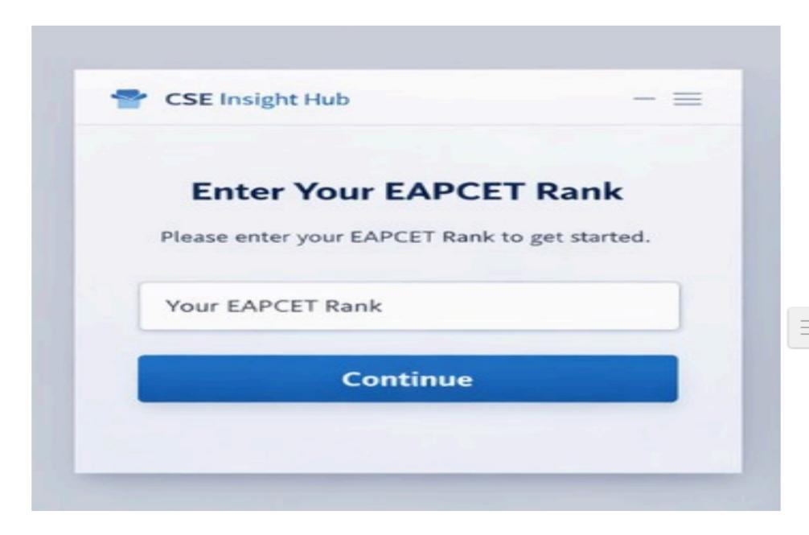

Trending Technologies Module – Theory Part

Introduction
The Trending Technologies Module in the CSE Insight Hub system helps students explore modern and high-demand technologies in the computer science field. This module provides information about various trending domains such as Artificial Intelligence, Cloud Computing, Cybersecurity, DevOps, Data Science, and Web Development. It guides students in selecting technologies based on their interests and career goals.

Objective
The objectives of this module are:
- To introduce students to trending technologies.
- To provide career awareness in the IT industry.
- To help students choose suitable technical domains.
- To improve learning and skill development opportunities.
Working Process
Step 1: User Access
The user opens the Trending Technologies page from the CSE Insight Hub dashboard.
Step 2: Technology Display
The system displays different trending technology categories with icons and titles.
Step 3: User Selection
The user selects any technology based on their interest.

Step 4: Information Processing
The system retrieves:
- Required skills
- Career opportunities
- Learning resources
Step 5: Result Display
The selected technology details are displayed to the user.

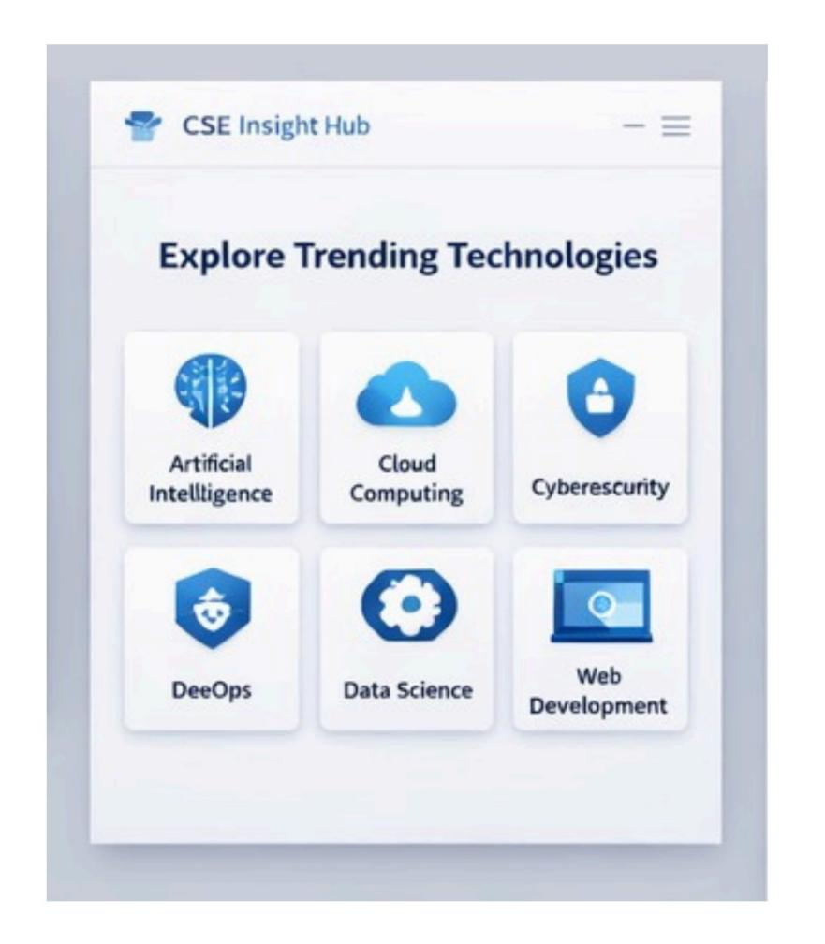

Interest & Skills Assessment Module – Theory Part

Introduction
The Interest & Skills Assessment Module in the CSE Insight Hub system is designed to identify a student’s interests, strengths, and problem-solving abilities. This module collects responses through interactive questions and analyzes them to recommend suitable technology domains and career paths. It helps students understand which field matches their skills and interests.

Objective
The objectives of this module are:
- To assess student interests and technical preferences.
- To identify problem-solving and analytical skills.
- To recommend suitable technology domains.
- To provide personalized career guidance.

Working Process
Step 1: User Access
The user opens the Interest & Skills Assessment page.
Step 2: Question Display
The system displays assessment questions with multiple-choice options.
Step 3: User Response
The user selects answers based on personal interests and skills.
Step 4: Data Analysis
The system analyzes:
- Technical interests
- Logical thinking ability
- Creative thinking ability
- Technology preferences

Step 5: Recommendation Generation
Based on the analysis, the system suggests suitable technology fields and career paths.

Step 6: Navigation
The user clicks the “Next” button to continue to the recommendation or results section.
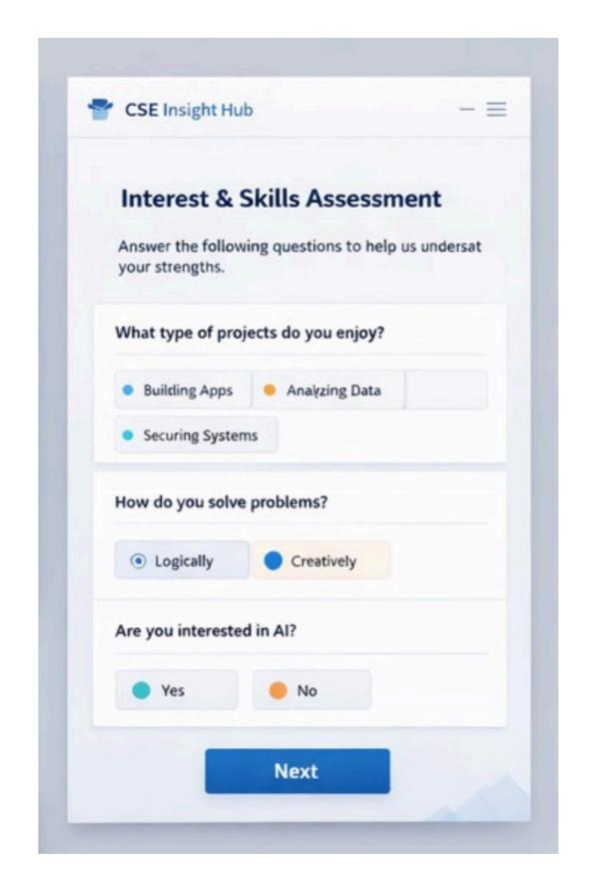

Career Recommendation Module – Theory Part

Introduction
The Career Recommendation Module in the CSE Insight Hub system provides personalized career suggestions based on the student’s EAPCET rank, interests, and skills assessment results. This module analyzes user data and recommends the most suitable technology domain and career path. It helps students make informed decisions regarding their academic specialization and future career opportunities.

Objective
The objectives of this module are:
- To recommend suitable career domains for students.
- To analyze student interests and assessment responses.
- To guide students toward industry-relevant technologies.
- To support better career planning and specialization selection.

Working Process

Step 1: Data Collection
The system collects:
- EAPCET rank
- Interest assessment responses
- Skill evaluation data

Step 2: Data Analysis
The system processes and analyzes the collected information using predefined recommendation logic.

Step 3: Career Recommendation
Based on the analysis, the system identifies the most suitable career domain for the student.

Step 4: Display Results
The recommended career path is displayed along with related specialization areas.

Step 5: College Navigation
The user clicks the “View Colleges” button to explore colleges offering the recommended specialization.
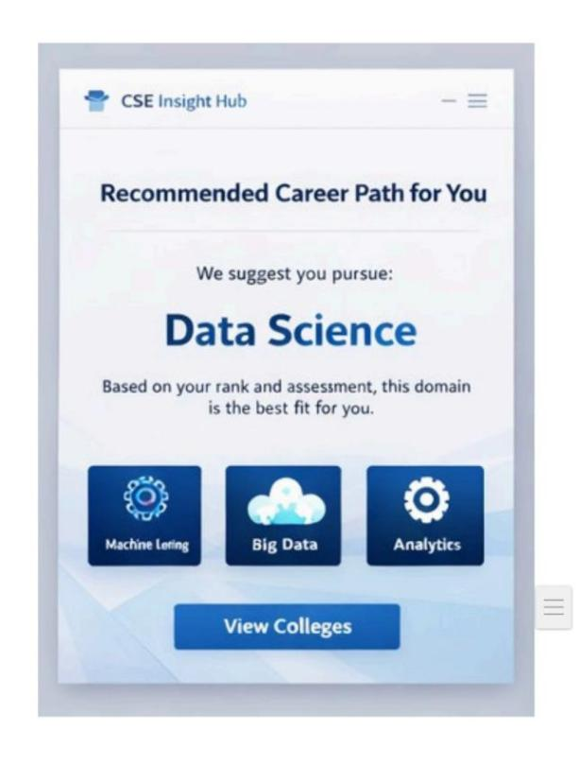

Benefits of Data Science Module – Theory Part

Introduction
The Benefits of Data Science Module in the CSE Insight Hub system provides students with information about the advantages and career opportunities available in the Data Science domain. This module helps students understand why Data Science is one of the most demanded and rapidly growing fields in the technology industry. It motivates students to explore the domain by highlighting its career scope, salary potential, and future opportunities.

Objective
The objectives of this module are:
- To educate students about the advantages of Data Science.
- To create awareness about career opportunities in the field.
- To motivate students to develop data-related skills.
- To help students understand industry demand and future growth.

Working Process

Step 1: User Access
The user opens the Benefits of Data Science page from the recommendation section.

Step 2: Information Display
The system displays different benefits of the Data Science domain using visual cards and descriptions.

Step 3: User Understanding
The user reads and understands the advantages, career scope, and opportunities available in Data Science.

Step 4: Career Awareness
The module helps the user evaluate whether the domain matches their interests and career goals.

5.4 RESULTS
The Results Module of the CSE Insight Hub system displays the final output generated after analyzing the student’s EAPCET rank, interests, and skills assessment responses. The system provides personalized recommendations to help students choose suitable career domains and colleges.

Results Obtained
- Successfully collected and analyzed student EAPCET rank data.
- Generated personalized career recommendations based on interests and skills.
- Identified suitable technology domains such as Data Science, AI, Cloud Computing, Cybersecurity, and Web Development.
- Provided specialization suggestions related to recommended domains.
- Predicted suitable colleges based on EAPCET rank.
- Displayed career opportunities and future growth areas.

CHAPTER 6
CONCLUSION AND FUTURE ENHANCEMENT
CONCLUSION:
The CSE Insight Hub project is developed to provide intelligent academic and career guidance for students by integrating EAPCET rank analysis, interest assessment, skill evaluation, technology recommendations, and college prediction into a single platform. The system aims to bridge the gap between students’ academic choices and future career opportunities by offering personalized recommendations based on their profile and interests.
The project begins with collecting the student’s EAPCET rank, which acts as the primary input for determining eligible colleges and suitable academic paths. The system then performs interest and skills assessment through interactive questions to understand student preferences, logical abilities, and technical interests. Based on the responses collected, the platform identifies suitable technology domains and generates career recommendations.
The implementation of the Trending Technologies Module helps students gain awareness of modern technologies such as Artificial Intelligence, Cloud Computing, Cybersecurity, DevOps, Data Science, and Web Development. This enables students to understand industry trends and make better career decisions according to market demands.
The Career Recommendation Module plays an important role by analyzing user inputs and providing personalized career suggestions. The recommendation engine identifies suitable domains and presents related specialization areas, helping students understand future opportunities and required skills. The inclusion of college suggestions further improves decision-making during admission and counseling processes.
The project also introduces a dedicated Benefits Module, which educates students about career growth, salary opportunities, industrial demand, and learning paths in recommended domains. This increases awareness and motivates students to enhance their skills and prepare for future careers.
Key Achievements:
The CSE Insight Hub project successfully achieved several objectives by integrating academic guidance, career recommendation, and technology awareness into a single platform. The major achievements of the project are presented below:

Personalized Career Recommendation System
The system successfully provides personalized career recommendations by analyzing student interests, skills assessment responses, and EAPCET rank details. This helps students identify suitable domains according to their abilities and preferences.

Integration of EAPCET Rank Analysis
The project implemented an EAPCET rank-based prediction mechanism that assists students in identifying suitable colleges and academic opportunities. This reduces confusion during admission and counseling processes.

Development of Interest and Skills Assessment Module
An interactive assessment module was developed to evaluate:
- Student interests
- Problem-solving abilities
- Technology preferences
- Analytical thinking skills
The collected information improves recommendation accuracy.

FUTURE ENHANCEMENTS:
The current implementation of the CSE Insight Hub provides effective career guidance and recommendation facilities; however, several advanced features can be added in future versions to improve functionality, intelligence, and user experience.

AI-Based Recommendation System
The current recommendation process follows predefined logic. In future development, Artificial Intelligence and Machine Learning algorithms can be integrated to generate more accurate and personalized recommendations.
Machine learning models can analyze:
- Student interests
- Academic performance
- Previous recommendation history
- Placement statistics
- Industry demand

REFERENCES

- Ian Sommerville, Software Engineering, 10th Edition, Pearson Education, 2015.
- Roger S. Pressman and Bruce R. Maxim, Software Engineering: A Practitioner’s Approach, 8th Edition, McGraw-Hill Education, 2014.
- Abraham Silberschatz, Henry F. Korth, and S. Sudarshan, Database System Concepts, 6th Edition, McGraw-Hill, 2011.
- Thomas H. Cormen, Charles E. Leiserson, Ronald L. Rivest, and Clifford Stein, Introduction to Algorithms, 3rd Edition, MIT Press, 2009.
- MDN Web Docs, “HTML, CSS and JavaScript Documentation.”
MDN Web Docs
- W3Schools — Reference for frontend development concepts and examples.
- GeeksforGeeks — Used for programming tutorials, algorithms, and coding references.
- GitHub — Version control and project repository hosting.
- Stack Overflow — Community-based programming discussions and debugging support.
- “Project Hub: Collaborative Platform for Student and Faculties,” ResearchGate, 2024.
- Open Source Society University, “Computer Science Curriculum.”
- “CS-Insights: A System for Analyzing Computer Science Research,” arXiv, 2022.

APPENDIX AND SAMPLE CODE
A.1 DATASET / USER DATA DESCRIPTION
The CSE Insight Hub system uses user-provided information and assessment data to generate personalized career recommendations, technology suggestions, and college predictions. The dataset consists of student details collected through different modules of the system.
A.2 SYSTEM MODULES / ARCHITECTURE

System Modules
The CSE Insight Hub system is divided into multiple modules to perform academic guidance, career recommendation, and college prediction functions. Each module performs a specific operation and collectively contributes to the overall system functionality.

1. EAPCET Rank Input Module
This module collects the EAPCET rank entered by the student. It acts as the initial stage of the system and validates the input before processing.
Functions:
- Accept student rank
- Validate input values
- Store rank information
- Forward data for processing
Input: EAPCET Rank
Output: Validated rank data

2. Interest & Skills Assessment Module
This module evaluates student interests, problem-solving abilities, and technical preferences through questionnaires.
Functions:
- Collect assessment responses
- Analyze interests
- Evaluate logical and analytical skills
- Identify technology preferences
Input: User responses
Output: Skill assessment data

3. Trending Technologies Module
This module introduces students to modern technology domains and career opportunities.
Technologies Included:
- Artificial Intelligence
- Cloud Computing
- Cybersecurity
- DevOps
- Data Science
- Web Development
Functions:
- Display technologies
- Provide career information
- Increase awareness

4. Career Recommendation Module
This module generates personalized career suggestions based on student assessment results and interests.
Functions:
- Analyze user profile
- Generate recommendations
- Suggest specialization areas
- Display career opportunities
Output Example: Data Science, Cloud Engineer, Cybersecurity Analyst

5. College Recommendation Module
This module predicts suitable colleges based on EAPCET rank and recommendation results.
Functions:
- Rank analysis
- College prediction
- Eligibility checking
- Display recommendations

6. Results Module
The Results Module displays the final output generated by the system.
Functions:
- Show recommended domain
- Display specialization areas
- Provide college suggestions
- Present final recommendations

A.3 TRAINING AND EXECUTION SETUP
he CSE Insight Hub system is trained using user inputs such as EAPCET rank, interests, skills assessment responses, and technology preferences to generate career recommendations and college predictions.

Training Setup
- Data Collection: EAPCET rank, interests, skills, preferences
- Data Validation: Input checking and verification
- Data Processing: Analysis of student responses
- Recommendation Generation: Career and college suggestions

Execution Setup
Hardware Requirements
- Processor: Intel Core i3 / i5
- RAM: 4 GB Minimum
- Storage: 20 GB Free Space
Software Requirements
- Operating System: Windows / Linux
- Python 3.x
- VS Code
- MongoDB / MySQL
- Chrome Browser

Execution Steps
- Install Python and required libraries
- Configure database
- Run application using:
python app.py
- Open browser:
- http://localhost:5000

Execution Flow
User Input → Assessment → Recommendation → College Prediction → Results
A.4 DEPLOYMENT DETAILS
he CSE Insight Hub system is deployed as a web-based application for providing career guidance and college recommendations.

Deployment Environment
- Frontend: HTML, CSS, JavaScript / React
- Backend: Python (Flask)
- Database: MongoDB / MySQL

Deployment Steps
- Configure database and dependencies
- Install required libraries
- Run application:
python app.py
- Access application:
http://localhost:5000

Deployment Features
- Secure data handling
- Responsive interface
- Scalable architecture
- Cloud deployment support (AWS, Azure, Google Cloud)

A.5 RESULTS
The CSE Insight Hub system successfully generated personalized career recommendations, technology suggestions, and college predictions based on student EAPCET rank, interests, and skills assessment responses. The system helped students identify suitable domains, specialization areas, and career opportunities, supporting better academic and career decision-making.

A.6 BENEFITS OF THE SYSTEM
- Provides personalized career recommendations based on student interests and skills.
- Assists students in college selection using EAPCET rank analysis.
- Improves career decision-making and academic planning.
- Increases awareness of trending technologies and career opportunities.
- Reduces dependency on manual counseling methods.
- Offers specialization and technology guidance.

